Daniel Fryer
Assignment 3.2 setting up landing page
GitHub landing page URL: https://xcitedmonkie.github.io/csd-340/
HTML Validation:
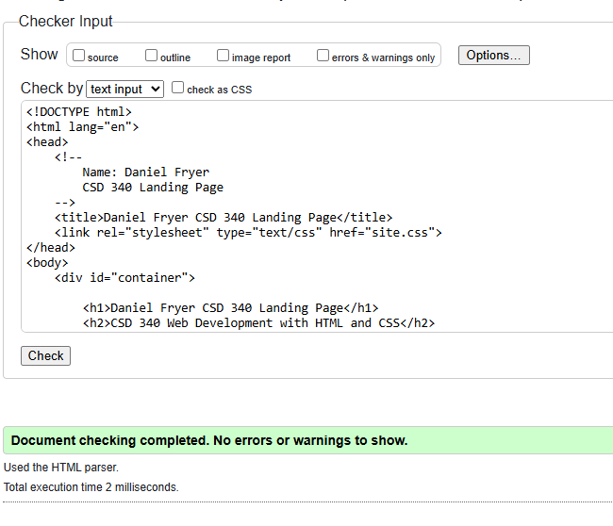
CSS Validation:
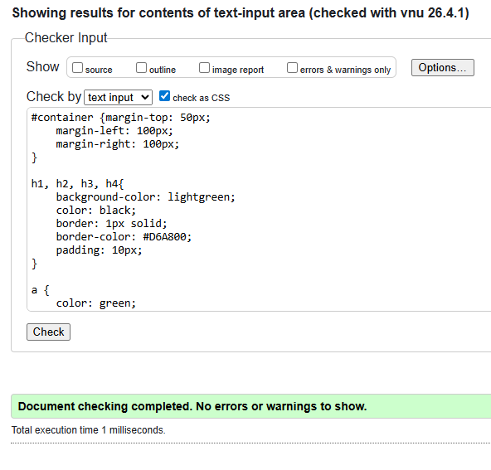

SITE:
